**Section 4-1: The Founding of the Fourfold Assembly**

In the previous section, (section 4) we explored how the ascetic Siddhartha attained the supreme enlightenment and became the Fully Awakened Buddha. Now, we turn our attention to the profound moment when the Blessed One established the Fourfold Assembly—bhikkhus (monks), bhikkhunis (nuns), upāsakas (laymen), and upāsikās (laywomen)—the foundation upon which the Dhamma would take root and flourish for the welfare of countless beings.

**Preparing to Teach the Dhamma**

Having awakened to the ultimate truth, the Buddha, the Compassionate One, did not keep his realization to himself. Out of boundless loving-kindness, he resolved to gather disciples who would transcend worldly bondage and become bearers of the Dhamma, guiding others beyond the clutches of Māra.

Yet, Māra, the tempter, knowing that the Buddha’s teachings would liberate beings from his grasp, sought to dissuade him from sharing the Dhamma. The scriptures recount this moment:

Māra spoke: *[1]*

*“If you have discovered the path, the secure way leading to the Deathless, then walk it alone. Why trouble yourself instructing others?”*

But the Blessed One, unwavering in his resolve, replied:

*“There are those seeking the far shore, longing to cross beyond the realm of Death. When they ask, I reveal the path—free from all clinging and beyond Māra’s reach.”*

Thus, the Buddha set in motion the great wheel of the Dhamma, illuminating the path of liberation for all who sought to awaken.

The relinquishing of all acquisitions, *(nirūpadhi*) which are the bondage of Māra.

**The Fourfold Assembly**

The Fourfold Assembly—bhikkhus (monks), bhikkhunis (nuns), upāsakas (laymen), and upāsikās (laywomen)—was established to uphold and transmit the Dhamma and Vinaya, the Buddha’s teachings and discipline. The primary purpose of forming this assembly was to preserve the Buddha’s teachings in their true essence, ensuring that both the Dhamma and Vinaya remained intact. Furthermore, it was to serve as a guiding force, spreading the Good Dhamma for the welfare and happiness of beings, not only in their present lives but also in future existences.

The Buddha himself affirmed this vision shortly after his enlightenment, expressing his determination to establish a strong community of monks, nuns, and lay followers who would safeguard and propagate the Buddha Sāsana (Dispensation).

**The Buddha’s Resolve to Establish the Sāsana**

In the Mahāparinibbāna Sutta (DN:16), the Buddha recalls an encounter with Māra soon after his awakening at Uruvelā, on the banks of the River Nerañjarā, beneath the Goatherd’s Banyan tree. Māra, realizing that the Blessed One’s teachings would liberate countless beings, attempted to persuade him to enter final Nibbāna without teaching others:

Māra said:  
*“May the Blessed One now attain final Nibbāna. May the Well-Farer now attain final Nibbāna. Now is the time for the Blessed One’s final Nibbāna.”*

But the Buddha, steadfast in his great compassion, replied:

*“Evil One, I shall not take final Nibbāna until I have disciples—monks, nuns, laymen, and laywomen—who are accomplished, trained, and learned, who are bearers of the Dhamma, skilled in explaining it, and who will spread this path of wondrous benefit. I shall not take final Nibbāna until this holy life is well established, flourishing, widely known, and proclaimed far and wide for the welfare of many.”*

**The Buddha’s First Missionaries**

The Buddha’s resolve to spread the Dhamma in all directions was further demonstrated when he addressed his first sixty disciples, instructing them to go forth and share the path of liberation:

The Buddha said:  
*“Bhikkhus, I am freed from all snares, both celestial and human. You too, bhikkhus, are freed from all snares. Therefore, wander forth, O bhikkhus, for the welfare and happiness of the many, out of compassion for the world, for the benefit and well-being of both devas and humans. Let no two of you travel the same way. Teach the Dhamma, which is excellent in the beginning, excellent in the middle, and excellent in the end, with the right meaning and phrasing. Proclaim the perfectly complete and purified holy life. There are beings with little dust in their eyes who are perishing because they have not heard the Dhamma. Some will understand upon hearing it. I too shall go to Senānigama in Uruvelā to teach the Dhamma.”* [2]

(Details of the first sixty disciples are mentioned below.)

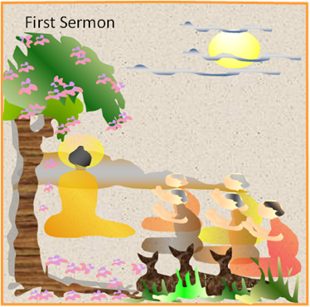

**The Five group of ascetics listening to the first sermon of the Buddha:** Afterwards they became the first disciples. Picture courtesy: SD.

**The Unsurpassed Trainer of Those to Be Tamed**

Through the boundless wisdom and compassion of the Buddha, we today have the precious opportunity to access the Dhamma—a legacy upheld by the Fourfold Assembly he so carefully established. Throughout the Sutta Piṭaka and certain sections of the Vinaya Piṭaka, we find countless accounts of the Blessed One’s extraordinary ability as the "Unsurpassed Trainer of Those to Be Tamed."

With his unparalleled skill, he transformed lives—guiding unbelievers to faith, leading the immoral toward virtue, softening the hearts of the cruel, and awakening wisdom in the deluded. Those once lost in ignorance and unwholesome ways became his devoted disciples, forming the sacred Fourfold Assembly—bhikkhus, bhikkhunis, upāsakas, and upāsikās—who carried forward the light of the Dhamma for the welfare of the world.

It is because of this supreme guidance that even today, we have access to the liberating teachings of the Buddha—timeless, ever-relevant, and leading all who seek the path toward true peace and awakening.

**The First Five Disciples**

The Blessed One’s journey as a teacher began with the ordination of his first five disciples, the former ascetics who had once practiced alongside him. At the conclusion of his first sermon—the Dhammacakkappavattana Sutta—these five ascetics, deeply moved and filled with confidence in the Buddha and his teaching, took refuge and were ordained as bhikkhus.

Thus, with the going forth of Venerable Koṇḍañña, Bhaddiya, Vappa, Mahānāma, and Assaji, the Bhikkhu Saṅgha was established, marking the formal beginning of the Buddha Sāsana—the Dispensation of the Blessed One.

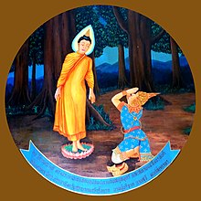Later, upon hearing the Anattalakkhaṇa Sutta (The Discourse on the Characteristics of Non-Self), all five attained arahantship, becoming fully liberated beings. With their awakening, there were now six noble ones in the world, and the light of the Dhamma had begun to spread for the welfare of countless beings. [3]

**Young Yas meeting the Buddha first time at the Deer Park, Isipatana:** a modern depiction in a Thai temple

Pictures courtesy: https://en.wikipedia.org/wiki/Yasa

**Yasa and His Friends Join the Dispensation**

During the Buddha’s first Rains Retreat, a young man named Yasa sought refuge in the Dhamma and, together with his four close friends—Vimala, Subāhu, Puṇṇaji, and Gavampati—ordained as bhikkhus. Soon after, fifty more of Venerable Yasa’s friends from the surrounding region also entered the Saṅgha, becoming disciples of the Blessed One. [4]

At this point, the Buddha’s Dispensation had grown to include sixty fully awakened arahants, all of whom hailed from Varanasi and its neighboring areas (see Section 13.1 for more details). With this strong foundation, the Dhamma began to spread, guiding more beings toward liberation.

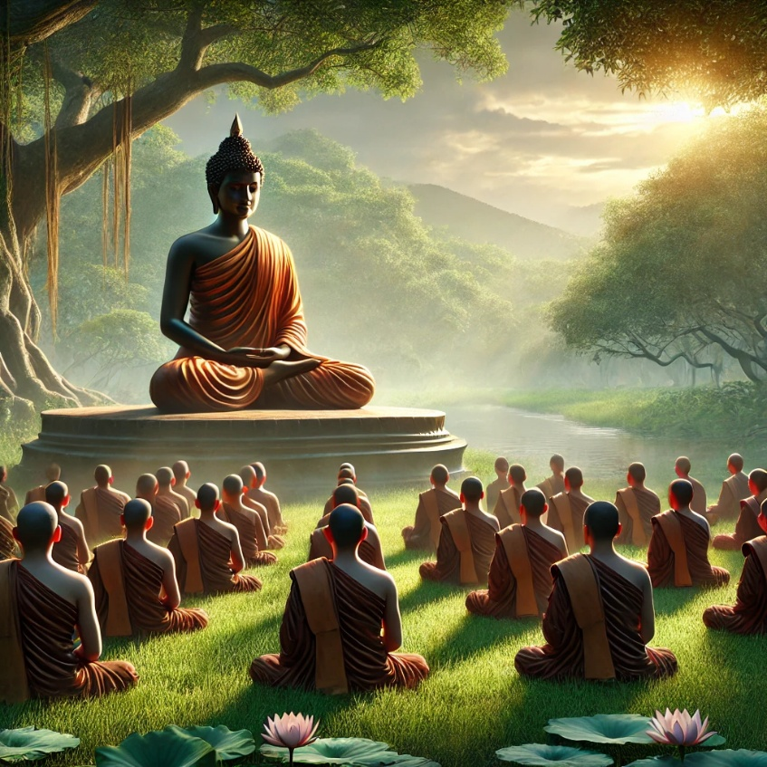

**The Buddha and his disciples meditating together:**

Image: specially created by Chat:GPT

**The Thirty Bhaddavaggīya Princes Join the Saṅgha**

While traveling from Isipatana to Uruvelā, the Blessed One encountered thirty young princes, known as the Bhaddavaggīya—"the fortunate ones." Blessed with the rare opportunity to hear the Dhamma directly from the Buddha, they awakened to the truth, attaining stream-entry. Filled with deep faith, they renounced worldly life and joined the Bhikkhu Saṅgha, further strengthening the growing monastic community, which now expanded to ninety bhikkhus. [5]

**The Kassapa Brothers and Their Students Enter the Saṅgha**

As described in **Section 13.2**, the Buddha’s encounter with Uruvelā Kassapa, his two brothers, and their large following of disciples was a pivotal moment in the early Saṅgha.

The scriptures record that on this occasion, the Blessed One ordained a thousand bhikkhus, marking a significant expansion of the monastic order.

**Sāriputta, Moggallāna, and Other Great Disciples Join the Buddha**

During his first visit to Rājagaha after attaining enlightenment, the Buddha met Sāriputta and Moggallāna, who would later become his two chief disciples. [6] Around the same time, other renowned disciples such as Venerable Mahākassapa and Venerable Rādha also entered the Saṅgha. [7]

As time passed, many other great disciples joined the Dispensation, including Venerable Upasena Vaṅgantaputta, Nanda, Rāhula, Dabba Mallaputta, Upāli, Anuruddha, Ānanda, Bhaddiya, Bhagu, Kimbila, and Mahākaccāna, among others. Each of these noble disciples played a vital role in preserving and spreading the Buddha’s teachings for the benefit of countless beings. [8]

**The Ordination of the Bhikkhunī Saṅgha: A Legacy of Liberation**

The establishment of the Bhikkhunī Saṅgha was one of the most profound and transformative moments in the Buddha’s Dispensation. It signified not only the Blessed One’s boundless compassion but also his unwavering commitment to providing the path of liberation to all, regardless of gender.

This momentous event took place in Vesālī, during the Buddha’s fifth Rains Retreat at the Great Wood Monastery. Queen Mahāpajāpati Gotamī, the Buddha’s maternal aunt and foster mother, along with five hundred Sakyan women, including Princess Yasodharā, renounced worldly life and were ordained as the first bhikkhunīs (Buddhist nuns). Their entry into the monastic community opened the doors for countless women to walk the noble path, attain wisdom, and realize the highest truth. As time passed, many other great women joined the Buddha’s dispensation, including Venerable bhikkhunis: Khema, Uppalavanna, Dhammadinna, Patachara, Mahabhaddakapilani among others. [9]

Even in the present day, the Bhikkhunī Saṅgha stands as a beacon of inspiration, proving that the path to awakening is open to all who seek it with sincerity and dedication.

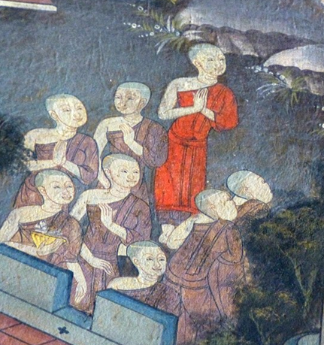

**Venrable Mahāpajāpati Gotamī and her Sakyan Ladies becoming Bhikkhunis-** Photo Dharma from Sadao, Thailand. Courtesy: https://en.wikipedia.org/wiki/Women_in_Buddhism

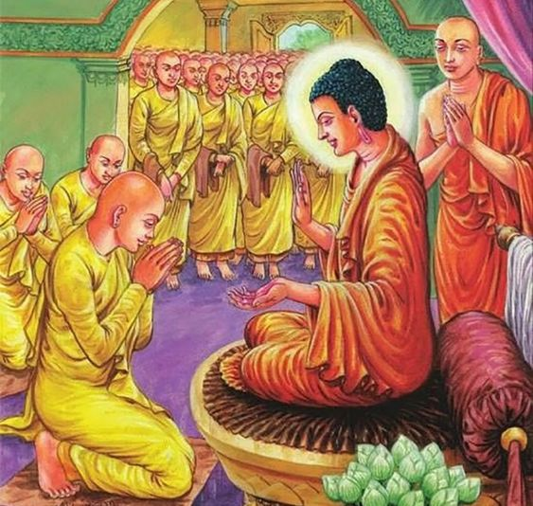

The Blessed One teaching the bhikkhuni sangha. Picture courtesy: https://in.pinterest.com/

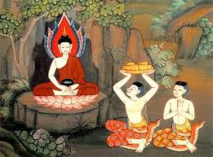 **Tapussa and Bhallika who were very fortunate to offer the first meal to the Buddha.** Picture courtesy: http://www.buddhistelibrary.org/library/

**Lay Followers of the Buddha**

The Blessed One did not establish the Saṅgha alone; he also extended his boundless wisdom and compassion to lay disciples (upāsakas and upāsikās), who became the other two pillars of the Fourfold Assembly.

According to the scriptures, lay followers did not merely offer material support to the Buddha and the Saṅgha; they also deeply engaged with the Dhamma, diligently practiced it, and attained various noble states—from stream-entry to the non-returner stage. Their unwavering faith and commitment ensured the flourishing of the Buddha’s teachings in both monastic and lay communities.

The first to take refuge as lay followers were Tapussa and Bhallika, two merchant brothers traveling from Ukkalā to Uruvelā. Near the place of the Buddha’s enlightenment, they encountered the newly awakened Blessed One, offered him his first meal, and became his first lay disciples.

(For a detailed account of this sacred encounter, see Section 4.)

According to the *Vinaya Pitaka*, while searching for his son, Bhikkhu Yasa’s father encountered the Buddha, listened to his teaching, and attained stream-entry. He became the first lay follower in the world to take refuge in the Triple Gem. [10] Later, he invited the Buddha and the Sangha for a meal offering. After the *dāna*, the Buddha delivered a progressive Dhamma discourse, through which Yasa’s mother and former wife also attained stream-entry. They became the first women in the world to take refuge in the Triple Gem as lay followers. [11]

As we saw in section 14-1, the Buddha had many lay followers from Magadha. According to the *Vinaya Pitaka*, King Bimbisāra, along with 120,000 brahmin householders, became followers of the Buddha after hearing his teaching. It is also mentioned that 110,000 of those brahmins, led by King Bimbisāra, realized the stainless vision of the Truth after a Dhamma discourse given by the Buddha at the royal palace. [12] Jīvaka Komārabhacca, a renowned physician of that time, also became a devoted lay follower and later served as the personal physician of the Buddha and the Sangha. [13]

When the Buddha first visited Kapilavatthu, [14] many Sakyans became his lay followers. Among them were Venerable Anuruddha’s elder brother, Mahānāma the Sakyan; Venerable Bhaddiya’s parents, Godha the Sakyan and his wife, Kālī Godha; as well as Nandiya the Sakyan, and several others. [15]

The scriptures illustrate how the community of lay followers expanded as people heard the Dhamma from the Blessed One or his great disciples. While the Buddha was in Sāvatthi, King Pasenadi Kosala and his queen, Mallikā, became faithful lay followers, as recorded in the *Saṃyutta Nikāya* (Kosala Saṃyutta). It is also mentioned that King Pasenadi’s daughter, along with her 500 attendants, took refuge in the Buddha and became lay followers.

In the *Aṅguttara Nikāya* (AN 1: Foremost Chapter), a list of the Buddha’s foremost lay followers is provided. Among the distinguished male lay followers were Sudatta Anāthapiṇḍika, Citta of Macchikāsaṇḍa, Prince Hatthaka of Āḷavi, Mahānāma the Sakyan, and Ugga of Vesālī. Among the outstanding female lay followers were Visākhā Migāramātā, Khujjuttarā Upāsikā, Uttarā Nandamātā, and Upāsikā Kuragara Kālī. [16]

◙ With this, we conclude this section. In the next section (5), we will focus on the greatness of the Blessed One.

**End Notes: Section 4-1**

1. SN4:24.
2. SN4:5 (5). * A similar statement was given in Vinaya Pitaka: VP: Mahakandha: 8: Translated by Bhikkhu Brahmali. * See also section 13.1.
3. SN22: 59 (Anatthalakkhana sutta. * This is the 2nd discourse of the Buddha, recorded at Vin I 13-14. The five bhikkhus are the first five disciples, who at this point are still trainees (sekha). They attain arahantship by the end of the discourse. Spk: Following the Dhammacakkappavattana Sutta (the first sermon), given on the full-moon day of Āsaḷha (July), the five were gradually established in the fruit of stream-entry. On the fifth of the following fortnight, he addressed them, thinking, “Now I will teach them the Dhamma for the destruction of the taints.”. see SN: Notes: 90 and VP: Mahākhandhaka: 6.
4. VP: Mahākhandhaka: 7. * Details of going forth of Venerable Yasa and his friends are given there.
5. See: section:13-2.
6. See: section:14-1 for more details
7. Ibid.
8. See: section:14-1 and 14:2. In AN:1: xiv: Chapter on Foremost: names of the Buddha’s foremost sangha-Bhikkhu & Bhikkhunis are given**. Note**: * to see the details of the disciples of the Buddha see also: KN: Thera-Theri Gatha & Thera Their Apadana * <https://dahampada.github.io/> in this website under the subchapter also gives some details of the disciples of the Buddha. * For more detailed biographical accounts of chief disciples of the Buddha: see: Great Disciples of the Buddha by Ven. Nyanaponika and Helmut Hecker.
9. See: AN1: Foremost Chapter for details of great bhikkhunis of the Buddha’s dispensation.
10. VP: Mahākhandhaka: 7.
11. Ibid.
12. Ibid.
13. VP: Mahākhandhaka:26.
14. This event is described in section:14-2.
15. For more details see <https://dahampada.github.io/>
16. For detail information see: Great Disciples of the Buddha by Ven. Nyanaponika and Helmut Hecker and <https://dahampada.github.io/>